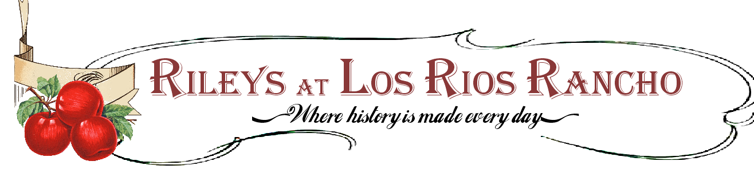

Company Picnics on the Ranch

39611 S. Oak Glen Rd.
Oak Glen Ca. 92399
(909) 797-1005
Event Coordinator: Rebekah Riley
rebekah@losriosrancho.com

Company Picnic guide: Summer 2016-Summer 2017

Dear Prospective Client,

We are honored that you are considering the Riley family to host your next event. All of our services and offerings come with the experience of over 23 years in the business of event planning and coordination by The Riley Family. We understands the importance of the atmosphere created by your event and how that represents you. We personally commit ourselves to providing a nostalgic environment that will garnish your time on the ranch with rustic charm.
Los Rios Rancho, largest apple farm in southern California, has been in operation since 1906 and consists of 325 acres and 8,000 producing Apple Trees.
Devon and Shelli Riley, operators of Riley’s at Los Rios Ranch and founding members of the Riley family in Oak Glen, invite you to review our custom event packages and look forward to the potential of working with new friends.

May your celebration be one of Good cheer and sweet memories
Happy Planning.

We provide the following unique event locations:

Blue Sky Park ~
Set on the green in front of our historic country store, your event will have back drops of our heirloom apple orchards stretching up to the base of Wilshire Peak.

Oak Knoll Park ~
Set your event under a canopy of majestic Oak Trees. The Knoll is shaded almost all year, and will provide the perfect feeling of intimacy with your staff family to ensure great atmosphere.

Frontier Farm~
Home of the Riley family and year round living history tours, the Frontiers offer a private 3 acre farm complete with historic encampment, heirloom garden kitchen, running streams, intimate oak forests. All set under the watchfull eye of Wilshire peak.
(Date availability is limited. Additional fees may apply)

“Walk in the Park” Package
~Meal and Meeting~
Pricing for a minimum of 75 guest, $60 for each additional guest
Friday…..Starting at $7,000
Saturday and Sunday…..Starting at $7,200
This package combines the perfect balance between in house and food and setup while allowing you the room for personal touches with games and a blank canvas for the event theme.
This package is available for either park locations from 12:00-3:00 pm
And includes…..
*White padded folding chairs *Tables complete with linen and basic farm décor *All necessary Utensils, plate wear, drink wear etc, *Golf Cart and driver, to transport guests from parking to event seating (Available in Oak Knoll Park only) *Portable boom box complete with microphone for announcements and music adapter
*Hors-devours: Cheese trays, Crackers, vegetable trays, and our homemade spinach dip
*Drinks: Our Farm Pressed Apple Cider, Tropical Iced tea, coffee, and water.*Your

Choice of meal:
~Our famous Tri-Tip/chicken, Roasted potatoes, Cowboy beans, dinner roll
~ Lemon Pepper Chicken; Rice Pilaf, Steamed Vegetables, Dinner Role
~Chicken Pie and Roasted Apple Butter Glazed Ham; Mashed Potatoes and Gravy, Steamed Vegetable and Dinner Roll
~Portabella Mushroom Lasagna, and Red Sausage Lasagna; Steamed Vegetables, and Dinner Roll
Served Buffet style
We will provide:
Two Folding Chalk signs to assist your guest with directions
Set up and take down of event sight
Necessary staff to accommodate the event

Additional Items:
Bottled sodas: to be added to the drink list: $3 additional per person (75 person minimum)
Caramel Apple Party Favors Wrapped with ribbon and displayed in an antique pushed cart…...$400 for a minimum of 75 guests $5 for each additional guest
“Chuck Wagon Supper Show”
~Rustic Dinner Event and Cowboy Entertainment~

Pricing for a minimum of 100 guest, $100 for each additional guest

Fridays…..Starting at $10,200
Saturdays and Sundays…..Starting at $10,500

With mountain peak and summer sunset as a backdrop you will feast and be entertained the Riley way. Let us prepare this old time western themed event to create an atmosphere that is sure to leave an impression on your guests for years to come.

This package is available on our Blue Sky park from 4:00-9:00 pm
and includes the following…
*Picnic table seating with rustic lanterns, gingham table cloths, spatter wear plates, and utensils.
*Campfire
*Lassoing for the little ones
*Gunny sack races
*Butter churning and ice cream making
*Chuckwagon back drop and frontier decor

Your meal will be prepared over an open fire to tempt the tastebuds of all your guests:
~Sirloin steak, dinner salad, dutch oven potatoes, and cowboy beans
~Complete with dutch oven farm fresh berry cobbler

Appetizers: Peanuts, pretzels, and popcorn served in rustic wooden barrels.
Drinks: Our Farm Pressed Apple Cider, lemonade, Tropical Iced tea, Cowboy coffee, and water.

Our House band will serenade you under a canopy of summer stars with cowboy classics such as “Happy Trails”, “Ghost Riders in the Sky”, and “Foggy Mountain Break Down” to name a few.

Additional items:
*Little Seedling Ranch: We will open up our petting zoo for your guests to enjoy and interact with all our farm animals.
$350 for up to 2 hours ($125 for one additional hour)

*Tractor drawn wagon ride: Enjoy an evening hayride through our heirloom apple orchards
$350: rides for approx. 75 guests. $5 per person additional after 75

“Frontier Farm Package”
~Rustic Farm Event with Historical activities~

Pricing for a minimum of 75 guests, $75 for each additional guest

Friday…..Starting at $7,800
Saturday and Sunday…..Starting at $8,000

This package provides an intimate and rustic event atmosphere under a canopy of sycamore trees. Experience historical farm life with living historian demonstrations and feast on
a custom meal appropriate for the setting.

This Package is Located at our Frontier Farm location set for 1:00-7:00 pm
and includes…

*Picnic table seating with rustic lanterns, gingham table cloths, spatter wear plates, and utensils.
*Campfire
*Frontier craft activities: Candle dipping, cider pressing, horse drawn hayride, cabin life talk
*Portable speaker system with microphone for announcement and music adapter

Frontier Meal your choice of:
*Meal A:
Starter of Chili and Corn bread
Stuffed chicken, Baked potato, and mixed greens

*Meal B
Starter of green salad and bread sticks
Tri-Tip, Roasted potatoes, and cowboy beans

Both meals are complete with a slice of pie for desert.

Additional Items:
Our house band…..starting at $800

Caramel Apple Party Favors Wrapped with ribbon and displayed in an antique pushed cart…...$400 for a minimum of 75 guests $5 for each additional guest

